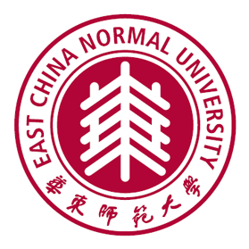**East China Normal University**

**Department of Educational Psychology**

**Multiple full-time open-rank positions**

East China Normal University (ECNU) is a top-rank research university in China. The Department of Educational Psychology (DEP) is a newly established department in the Faculty of Education. The DEP is intended to advance interdisciplinary research from a variety of perspectives and offers programs in the areas of educational psychology, child development, school counseling psychology, inquiry methodology at both Master’s and Doctoral levels. We are now inviting applications for open-rank full-time positions in the following research area.

* Cognitive and social process of innovative learning approaches
* Knowledge building and expertise development in subject matter domains
* Effective learning environment development in schools as well as technological and informal learning contexts
* Development and interventions of self, personality and character
* Emotion, motivation and volition（EMOVO）process in academic setting
* Mental health and interventions for early childhood and adolescence
* Inquiry methodology, especially in quantitative methods

**Required Qualifications:**

* Earned doctorate in the required area or closely related fields;
* Evidence of significant contribution to or great potential of scholarship in these fields;
* Evidence of ability to work collaboratively with others;
* Expertise and experiences to teach core coursework in the aforementioned area.

**Application materials:**

Interested applicants should submit: 1) a letter of interest that describes his/her research program; 2) a Curriculum vitae; 3) one or two representative scholarly publications (digital copies of the dissertation or dissertation draft for a PhD candidate); and 4) two letters of references.

Review of applicants will begin January 2018 and will continue until the positions are filled. Application materials should be sent electronically as either Word or PDF documents to Tianren Li (LTR1103@163.com).